
23CSE203
DATA STRUCTURES AND ALGORITHM

Submitted by
Name | B. Akshata
Roll.no | AV.SC.U4CSE25017
Section | CSE-A

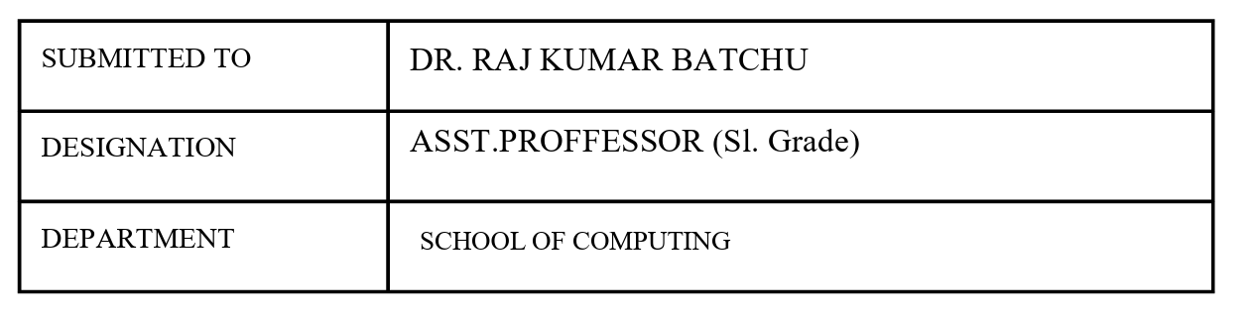
Credit | 5

Index
S.no | Title | Page.no | Remark
1. | A) A rocket launch system displays a countdown before launch. Instead of using loop, implement the countdown using recursion. Write a recursive program to display a countdown from n to 1 followed by launch.  B) Bank calculates the growth of an investment using compound intrest. The formula requires calculating powers, which can be implemented recursively. Write a recursive program to calculate p^{n}(power), where P=principal growth factor, n=no.of years.  C) Write a recursive progrsm to print the first n terms of fibanocci series  D) An hr department stores employee ids in a list develop a recursive program to search for a given employee id. Write a recursive function to search for an employee id in the list.  E) In a logistics the no.of possible ways to arrange n different parcels calculate using the factorial (n!). develop a recursive program to calculate the factorial of given number. | 4-13
2. | A) write a python program to perform linear search on the given input  B) Write a python program to perform binary search on the given input. Verify by taking sorted array and unsorted array as a list. | 14-18
3. | A) write a python program to sort the elements using a bubble sort technique. Take an input elements from the user.  B) Insertion sort  C)selection sort  D)Merge sort  E) Quick sort | 19-28

Week-1
A) Aim: A rocket launch system displays a countdown before launch. Instead of using loop, implement the countdown using recursion. Write a recursive program to display a countdown from n to 1 followed by launch.
Program:
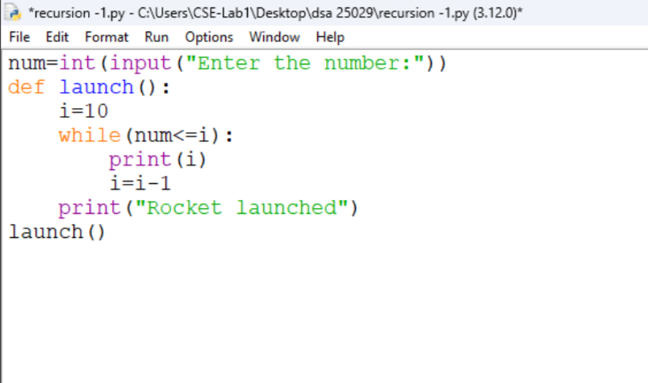
Output:
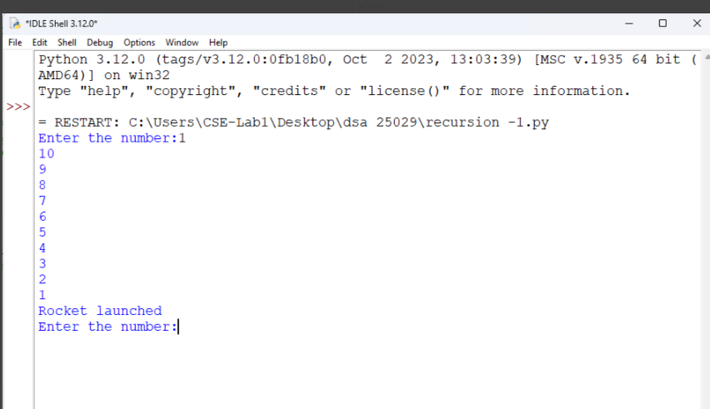
Explanation:
- It takes a number as input from the user and stores it in num.
- It creates a function named launch().
- It starts the countdown from 10 by assigning i = 10.
- It prints the value of i as long as num <= i.
- It decreases the value of i by 1 after each iteration.
- When the loop ends, it prints "Rocket launched" and executes the function using launch().
Error table:
s.no | Error obtained | Rectification
1. | Infinite loop | Iteration at correct place
2. | Calling function at wrong place | Placed with correct syntax

B) Aim: Bank calculates the growth of an investment using compound intrest. The formula requires calculating powers, which can be implemented recursively. Write a recursive program to calculate p^{n}(power), where P=principal growth factor, n=no.of years.
Program:
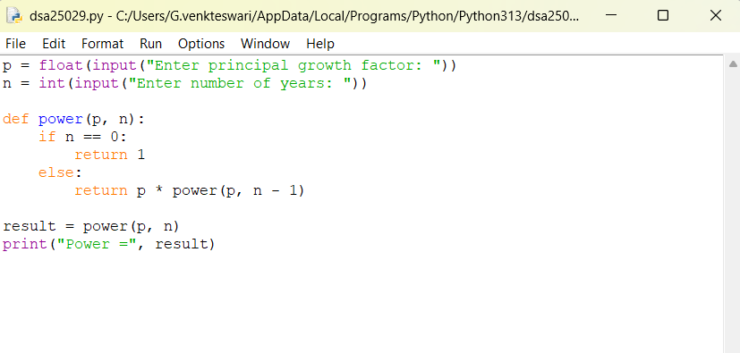
Output:
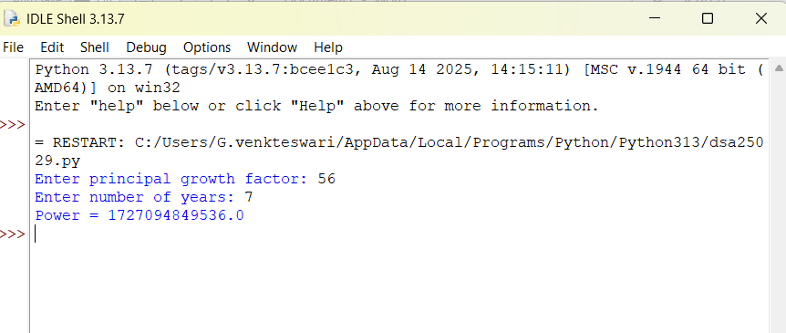

Explanation:
- The program takes the principal growth factor p and number of years n as input.
- It defines a recursive function power(p, n).
- If n is 0, the function returns 1 (base case).
- Otherwise, it returns p * power(p, n-1).
- The recursive calls continue until n becomes 0.
- The final value of pⁿ is displayed as the output.
- Error table:
s.no | Error obtained | Rectification
1. | Return 0 | Return 1
2. | print | return

C) Aim: Write a recursive progrsm to print the first n terms of fibanocci series
Program:
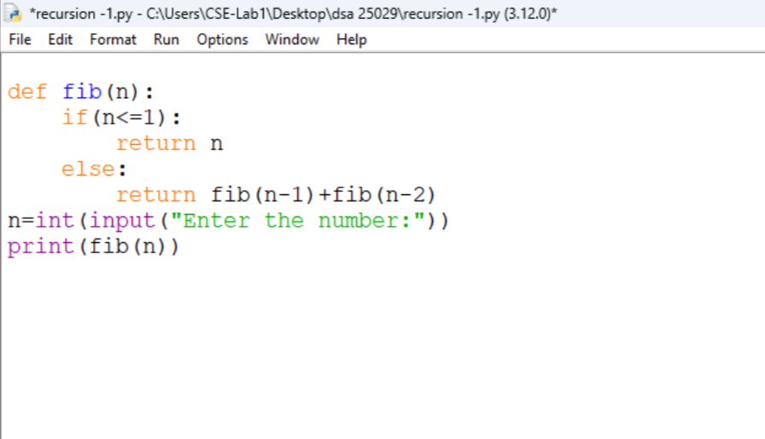
Output:
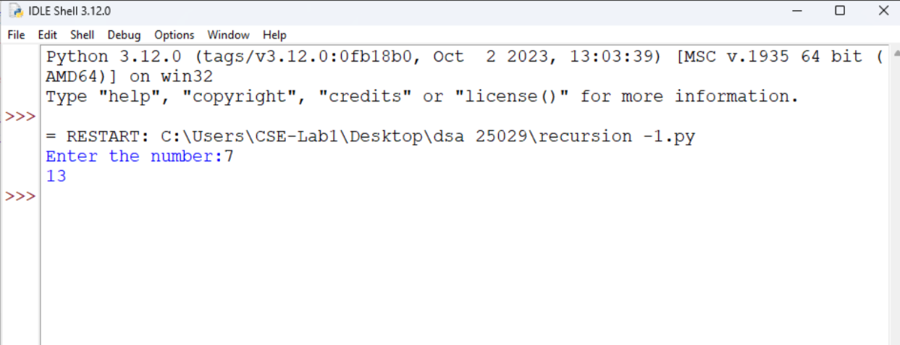

Explanation:
- For entering the number as input from user we defined as n
- We declared variable for formula.
- If input number is less than one then it return “1”
- Or it will goes under fibanocci iteration.
Error:
s.no | Error obtained | Rectification
1. | Forgot to declare n<=1 | rectified
2. | Formula mistake | rectified

D) Aim: An hr department stores employee ids in a list develop a recursive program to search for a given employee id. Write a recursive function to search for an employee id in the list.
Program:
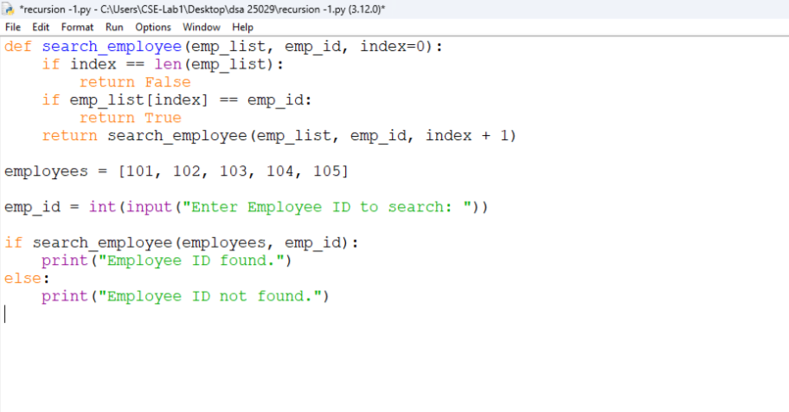
Output:
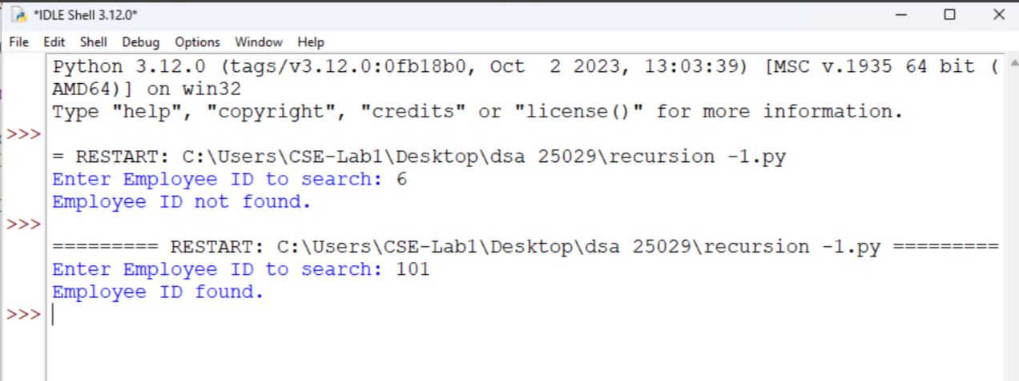

Explanation:
- The program creates a function to search for an employee ID in a list.
- It checks one employee ID at a time, starting from the first ID.
- If the entered employee ID matches the current ID, it returns True.
- If it does not match, the function moves to the next ID using recursion.
- If all employee IDs are checked and no match is found, it returns False.
- Finally, the program displays "Employee ID found." if the ID exists; otherwise, it displays "Employee ID not found."
- Error:
s.no | Error obtained | Rectification
1. | Emp lst | Emp_list
2. | print | Return

E) Aim: In a logistics the no.of possible ways to arrange n different parcels calculate using the factorial (n!). develop a recursive program to calculate the factorial of given number.
Program:
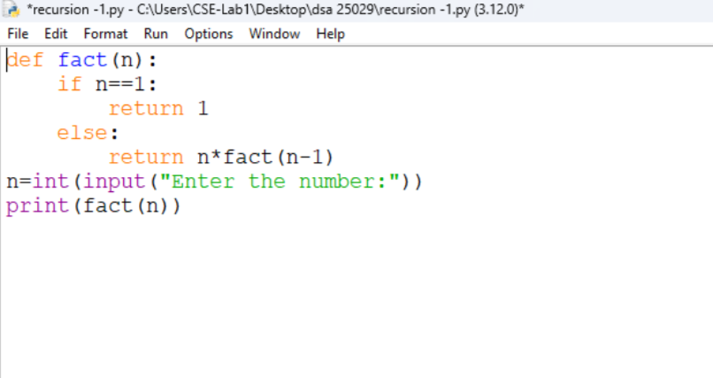
Output:
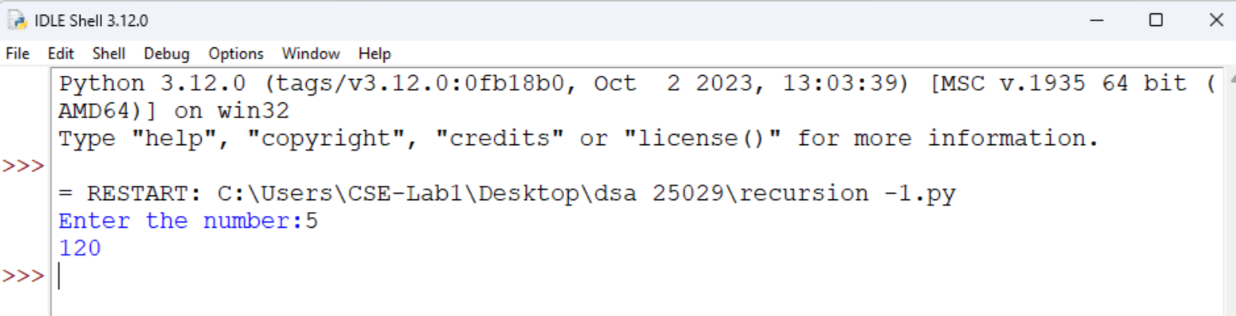

Explanation:
- The program defines a recursive function fact() to calculate the factorial of a number.
- It takes a number as input from the user.
- If the number is 1, the function returns 1 (base case).
- Otherwise, it multiplies the number by the factorial of the previous number (n-1).
- The recursive calls continue until the number becomes 1.
- Finally, the program prints the factorial of the given number.
Error table:
s.no | Error obtained | Rectification
1. | n+1 | n-1
2. | Syntax error | Rectified

WEEK-2
- AIM: Write a python programm to perfor linear search on the given input.
Program:
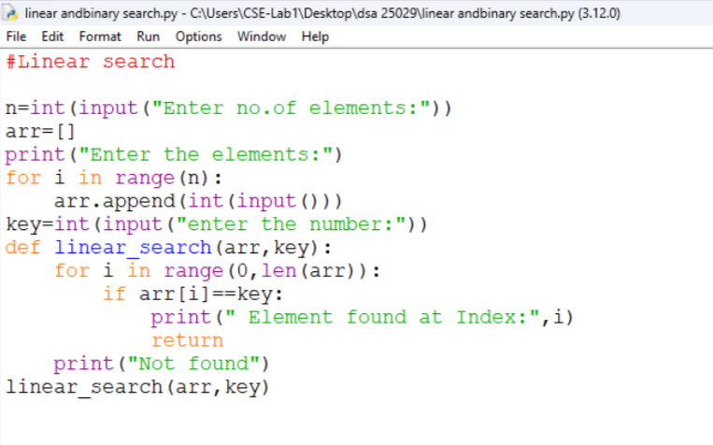
Output:
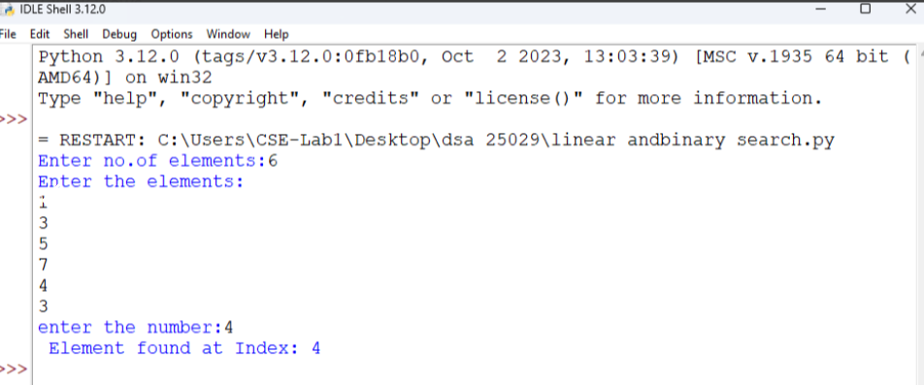

Explanation:
- In linear search we can append elements in sorted or unsorted way also.
- After placing the target we need to check the all the elements in a order.
- The time complixity is O(n).
- The target element may be found at beginning or last or at middle.
Error table:
s.no | Error obtained | Rectification
1. | Return placed in wrong place | Corrected later
2. | Calling the function | Rectified

B) Aim: Write a python program to perform binary search on the list.
Program: Unsorted
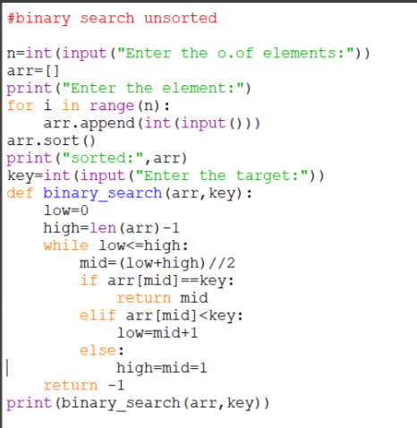
Output:
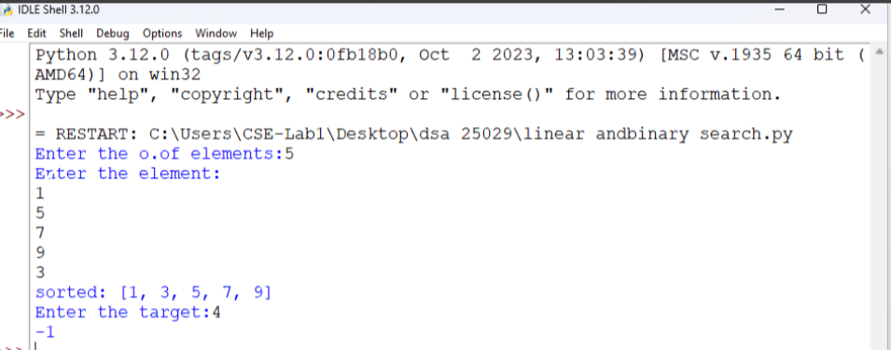

Program: Sorted
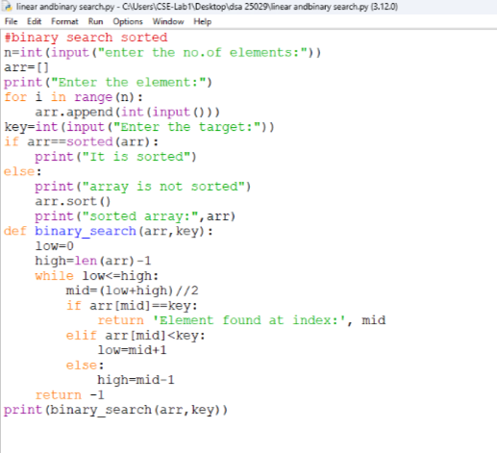
Output:
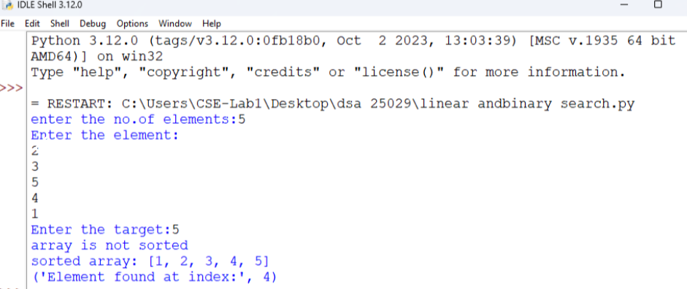

Explanation:
- The binary search should always executed in sorted order.
- Either it can be ascending or descending order.
- So the program is in unsorted order so we need to do sorting first later the binary search is executed.
- Error table:
s.no | Error obtained | Rectification
1. | Mistakes in main logic | Rectified
2. | Errors in conditions | Rectified

WEEK-3
A)Aim: Write a python programme to sort the elements using a bubble sort technique. Take an input elements from the users.
Programme:
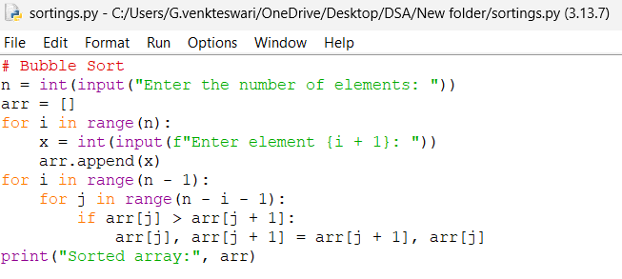
Output:
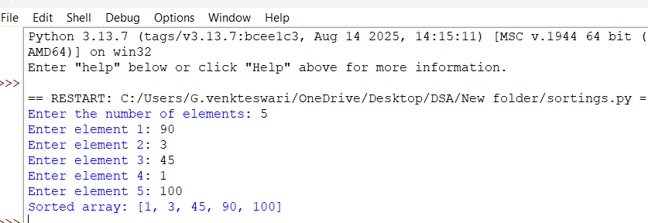
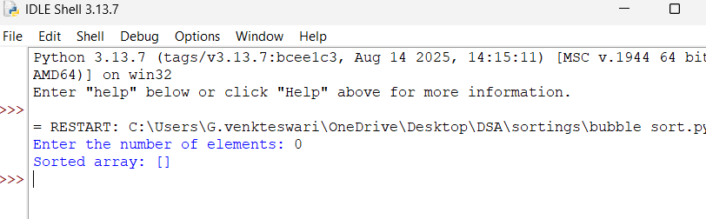

Explanation:
- n stores the number of elements, and an empty list arr is created.
- The first for loop takes n numbers from the user and adds them to arr.
- The second loop controls how many times the sorting process is repeated.
- The inner loop compares two neighboring elements: arr[j] and arr[j+1].
- If the first element is bigger, they are swapped using arr[j], arr[j+1] = arr[j+1], arr[j].
- Finally, print() displays the array in ascending order.
Error table:
s.no | Error obtained | Rectification
1. | Mistakes in main logic | Rectified
2. | Errors in conditions | Rectified

B)Aim: Write a python programme to sort the elements using a insertion sort technique. Take an input elements from the users.
Programme:
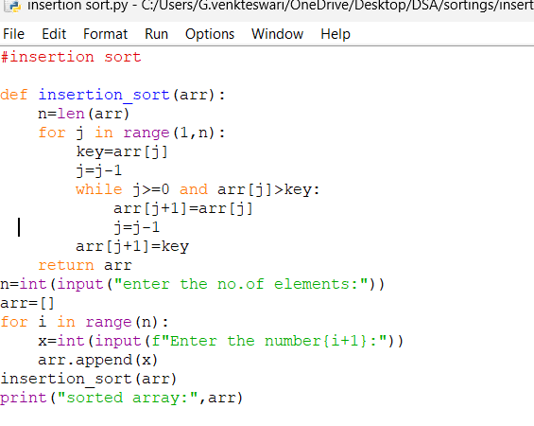
Output:
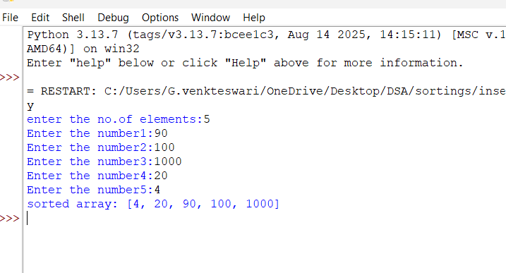

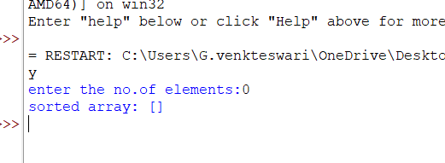
Explanation:
- insertion_sort(arr) takes the array and finds its length using n = len(arr).
- The for loop starts from the second element because the first element is considered already sorted.
- key = arr[j] stores the current element that we want to place in the correct position.
- The while loop moves bigger elements one position to the right.
- arr[j+1] = key places the current element in its correct position.
- Finally, the function returns the sorted array, and print() displays it in ascending order.
Error table:
S.no | Errors | Rectification
1. | Error in main logic | Rectified
2. | Errors in condition | rectified

C)Aim: Write a python programme to sort the elements using a selection sort technique. Take an input elements from the users.
Programme:
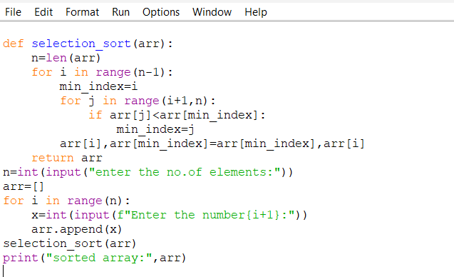
Output:
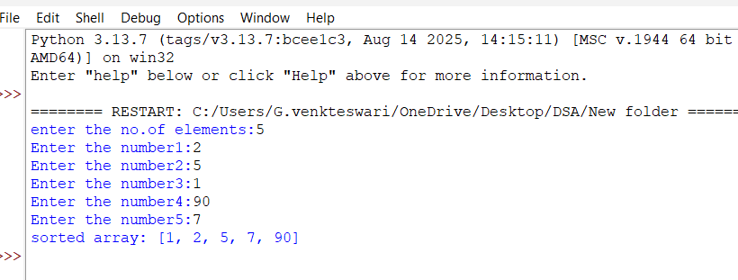

Explanation:
- n = len(arr) finds the total number of elements in the array.
- The outer for loop selects each position where the smallest element should be placed.
- min_index = i assumes that the current position contains the smallest element.
- The inner for loop compares the remaining elements and finds the smallest element's index.
- arr[i], arr[min_index] = arr[min_index], arr[i] swaps the smallest element with the current element.
- After all iterations, the array is sorted in ascending order and print() displays it.

Error table:
S.no | Errors | Rectification
1. | Error in main logic | Rectified
2. | Errors in condition | rectified

D)Aim: Write a python programme to sort the elements using a merge sort technique. Take an input elements from the users.
Programme:
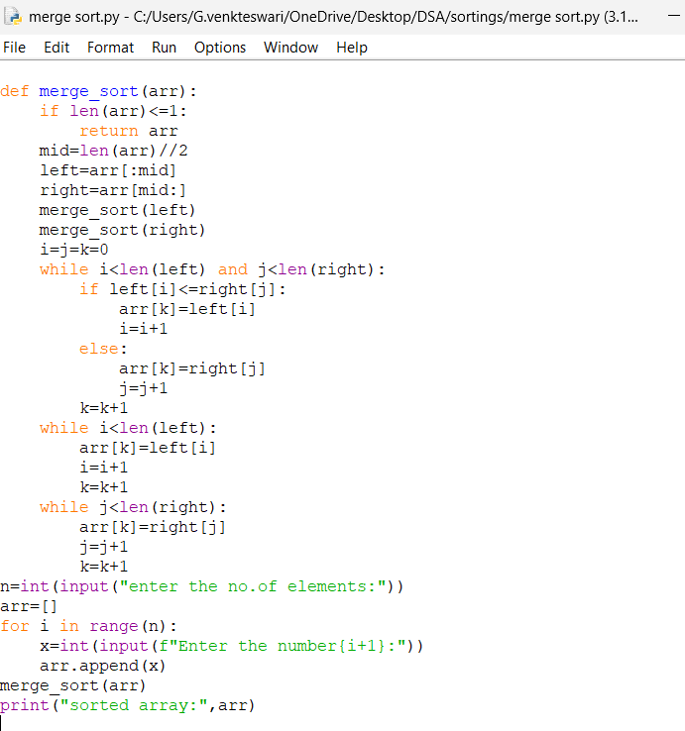
Output:
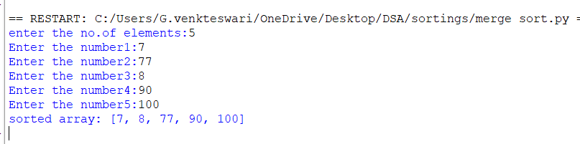
Explanation:
- if len(arr) <= 1 checks if the array has 0 or 1 element; if yes, it is already sorted.
- mid = len(arr)//2 finds the middle and divides the array into left and right parts.
- merge_sort(left) and merge_sort(right) recursively divide both parts into smaller parts.
- i = j = k = 0 creates indexes to compare elements from the left part, right part, and original array.
- The while loops compare elements and put the smaller element first into the original array.
- Finally, the remaining elements are added, and print() displays the sorted array in ascending order.
Error table:
S.no | Errors | Rectification
1. | Error in main logic | Rectified
2. | Errors in condition | rectified

E)Aim: Write a python programme to sort the elements using a merge sort technique. Take an input elements from the users.
Programme:
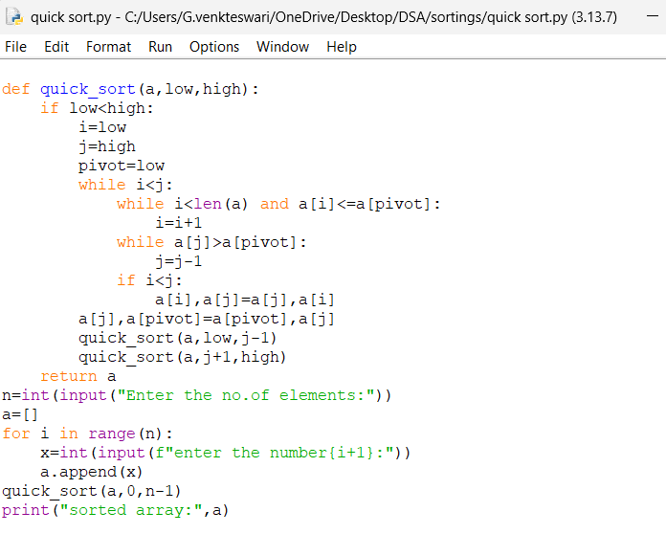
Output:
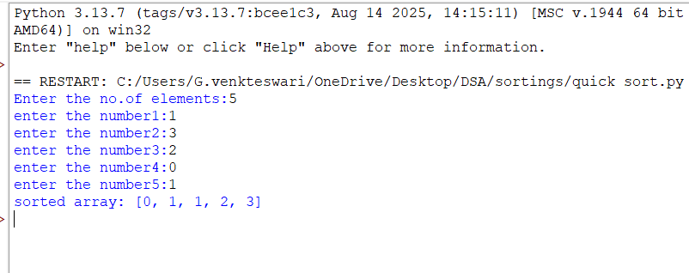
Explanation:
- quick_sort(a, low, high) sorts the elements between the low and high indexes.
- pivot = low selects the first element as the pivot.
- i moves from the left and finds an element greater than the pivot, while j moves from the right and finds an element smaller than or equal to the pivot.
- If i < j, a[i] and a[j] are swapped.
- After the loop, a[j] and the pivot are swapped, putting the pivot in its correct position.
- quick_sort() is called again for the left and right parts, and finally the array is printed in sorted order.
Error table:
S.no | Errors | Rectification
1. | Error in main logic | Rectified
2. | Errors in condition | rectified

